**Run the K-means clustering algorithm for the below data set, and study the clusters formed in WEKA.**

**Procedure:**

Step 1: In the preprocessing interface, open the Weka Explorer and load the required dataset, and we are taking the iris.arff dataset.

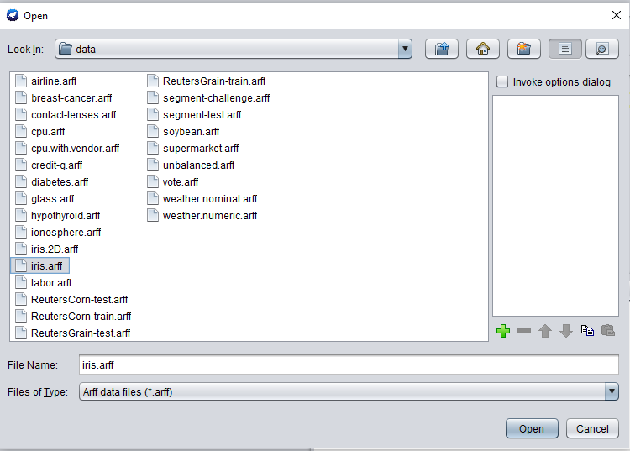

Step 2: Find the ‘cluster’ tab in the explorer and press the choose button to execute clustering. A dropdown list of available clustering algorithms appears as a result of this step and selects the simple-k means algorithm.

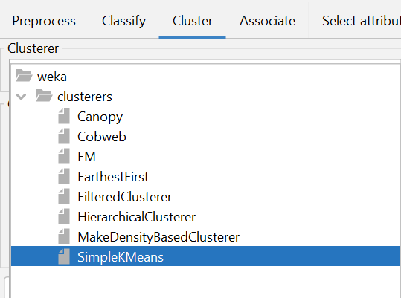

Step 3: Then, to the right of the choose icon, press the text button to bring up the popup window shown in the screenshots. We enter three for the number of clusters in this window and leave the seed value alone. The seed value is used to generate a random number that is used to make internal assignments of instances of clusters.

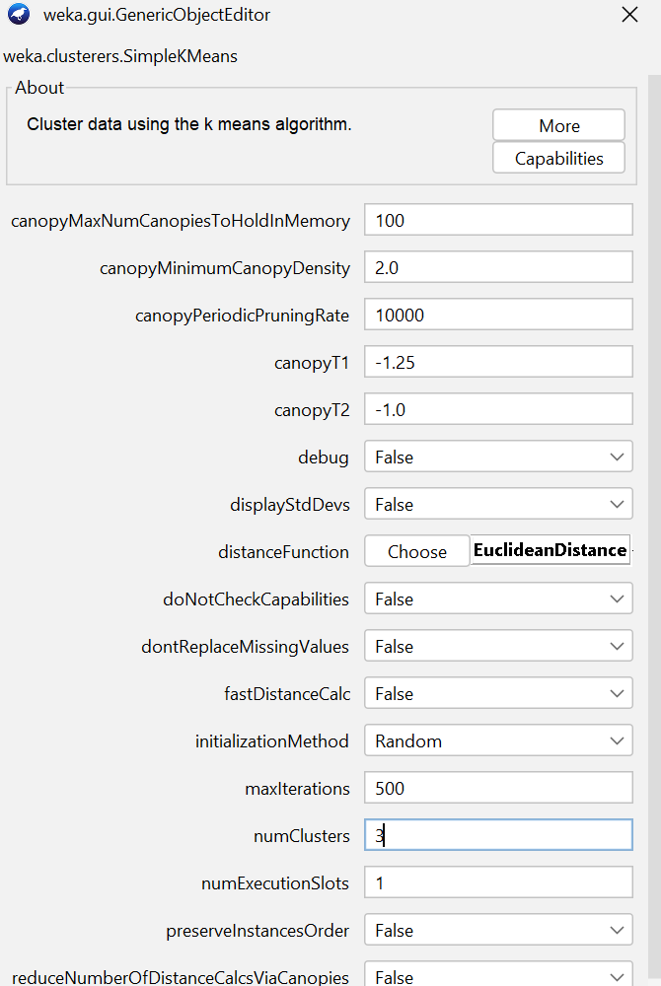

Step 4: One of the choices has been chosen. We must ensure that they are in the ‘cluster mode’ panel before running the clustering algorithm.

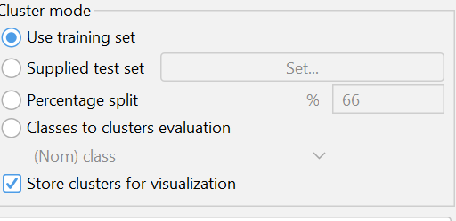

Step 5: Click on the ignore attribute and select class and select the start button

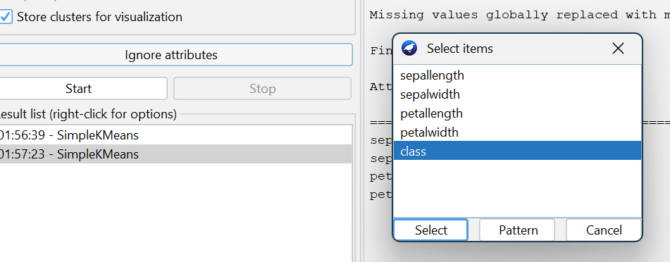

Step 6: right click on SimpleKMeans and select Visualize Cluster assignments to visualize the cluster

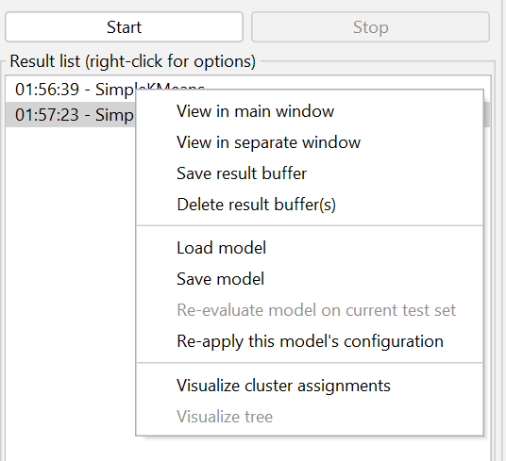 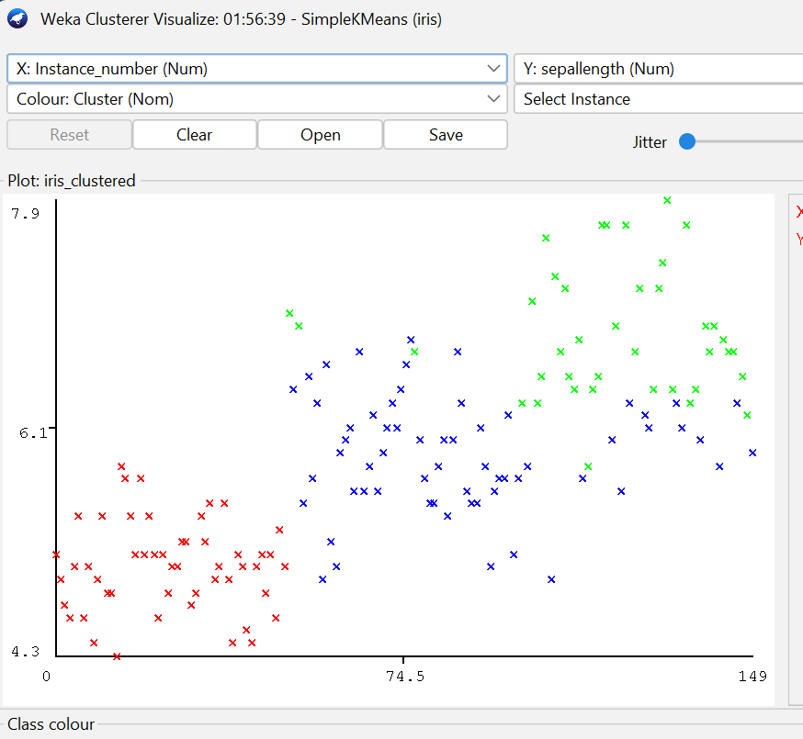

Following results are shown. Which show final cluster centroid and number of iteration

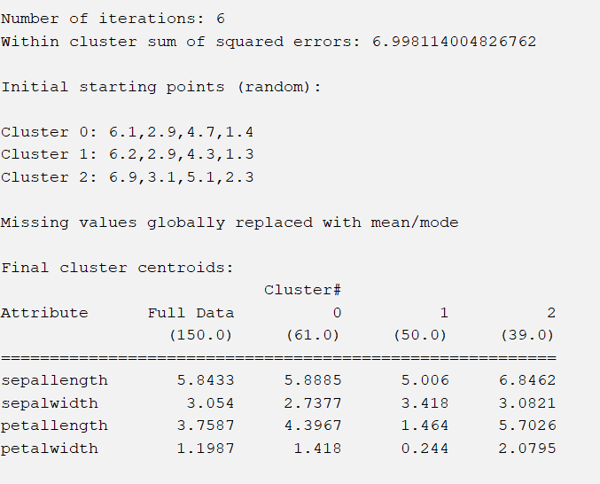

Python code

